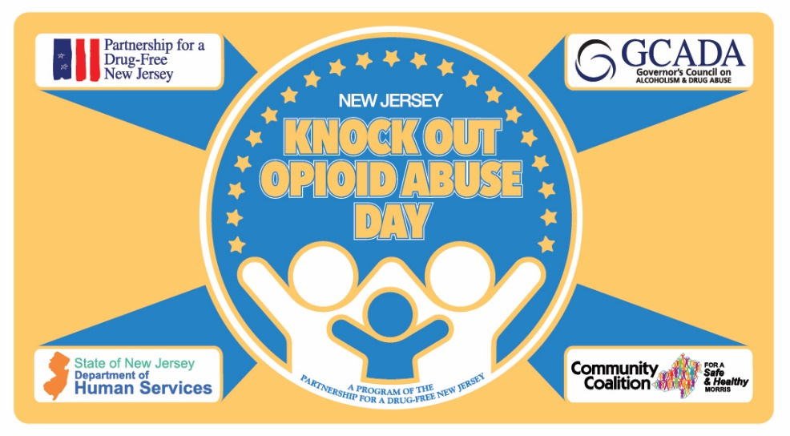
Opioid Fact Sheet
Recent Years
- There were 107,622 drug overdose deaths in the United States during 2021, according to preliminary data, an increase of nearly 15 percent from the 93,655 deaths estimated in 2020
- Overdose deaths that involved opioids increased from 70,029 in 2020 to 80,816 in 2021.
- The COVID-19 pandemic has caused an increase in the number of Americans using drugs. CDC researchers found roughly 13 percent of people surveyed either began using drugs during the pandemic or increased their use of illicit substances.
Since 1999
- Overdose deaths involving opioids, including prescription opioids, heroin, and synthetic opioids (like fentanyl), have increased by more than eight times since 1999.
- More than 932,000 people have died since 1999 from a drug overdose.
- From 1999 to 2020, more than 263,000 people died in the United States from overdoses involving prescription opioids.
- Overdose deaths involving prescription opioids nearly increased by five times from 1999 to 2020.
Prescription Opioids
- In 2020, an average of 44 people died each day from overdoses involving prescription opioids, totaling more than 16,000 deaths.
- Opioids used to treat pain:
  - Roughly 21 to 29 percent of patients prescribed opioids for chronic pain misuse them.
  - Between 8 and 12 percent of people using an opioid for chronic pain develop an opioid use disorder.
  - An estimated 4 to 6 percent who misuse prescription opioids transition to heroin.
  - About 80 percent of people who use heroin first misused prescription opioids.
- By age group:
  - Misuse of prescription drugs is highest among young adults ages 18 to 25, with 14.4 percent reporting nonmedical use in the past year.
  - Among youth ages 12 to 17, 4.9 percent reported past-year nonmedical use of prescription medications.
Fentanyl
- Overdoses involving synthetic opioids (primarily fentanyl) increased to 71,238 in 2021 from 57,834 such deaths in 2020. More than 36,000 people died from overdoses involving synthetic opioids in 2019.
- The rate of drug overdose deaths involving synthetic opioids other than methadone increased 56 percent, from 11.4 per 100,000 people in 2019 to 17.8 in 2020.
- Overdose deaths involving synthetic opioids were nearly 18 times higher in 2020 than in 2013.
- In New Jersey, the total number of overdose deaths involving synthetic opioids increased from 2,221 in 2019 to 2,331 in 2020, a 5 percent rise.
New Jersey
- New Jersey emergency room visits for substance use disorder increased nearly 30 percent from 2019 to 2020.
- There were 3,124 suspected drug overdose deaths in New Jersey in 2021.
- New Jersey emergency medical services and law enforcement administered naloxone 18,423 times during 2021.
- A 2016 Partnership for a Drug-Free New Jersey (PDFNJ) study, found that nearly one in three parents of New Jersey middle school students do not believe there is a link between pain killers prescribed for things like sports injuries and wisdom tooth removal and the rising use of heroin in New Jersey. The study also found that less than 50 percent of parents of New Jersey Middle School students feel they are knowledgeable about heroin.

More Information
- Over two-thirds of opioids prescribed by dentists are related to dental surgery, according to the 2018 study.
- A 2016 University of Pennsylvania study found that each year more 100 million prescription opioid pills had gone unused following wisdom teeth removal.
- Male adolescent athletes who participated in competitive sports across a three-year study period had two times greater odds of being prescribed painkillers during the past year and had four times greater odds of medically misusing painkillers (i.e., using them to get high and using them too much) compared to males who did not participate in competitive sports.
- Legitimate opioid use before high school graduation is independently associated with a 33 percent increase in the risk of future opioid misuse after high school.
- According to the American Academy of Pediatrics, the use of prescribed opioids before the 12th grade is independently associated with future opioid misuse among patients with little drug experience and who disapprove of illegal drug use.
- According to the Centers for Disease Control (CDC), women are more likely to have chronic pain, be prescribed prescription pain relievers, be given higher doses, and use them for longer time periods than men. Women may become dependent on prescription pain relievers more quickly than men.
- 91 percent of New Jersey residents agree that physicians should be legally required to discuss the risk of developing either a physical or psychological dependency on the prescription pain medication with patients prior to prescribing it and two-thirds believe that physicians discussing the potential of dependencies with patients will help reduce the number of individuals who ultimately become addicted to the pain medications.
- One of the most tangible examples of the dangers of misusing prescription drugs comes from the opioid crisis, which the Council of Economic Advisers (CEA) estimates cost $696 billion in 2018—or 3.4 percent of GDP—and more than $2.5 trillion for the four-year period from 2015 to 2018.

