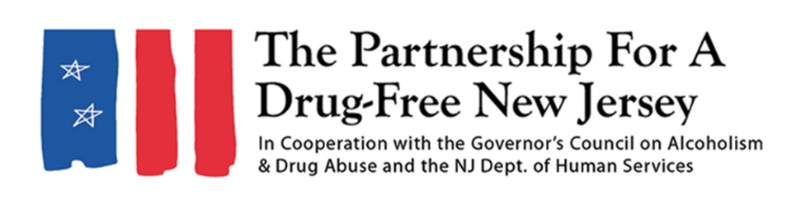

Dear [NAME OF FAITH LEADER],
The opioid crisis continues to take a tragic toll on New Jersey. Last year, more than 3,000 people in the state died of drug overdoses, a majority of which can be attributed to opioids, such as prescription painkillers, heroin and synthetic opioids including fentanyl.
This crisis has affected people of all backgrounds, regardless of wealth, race, religion or age, and it is likely that members of your congregation have been impacted, either directly or indirectly, by this epidemic.
It is vital that communities and families throughout the state are aware of the dangers of prescription opioids and their link to heroin and fentanyl, as well as actions that can be taken to prevent opioid misuse. That effort will continue here in New Jersey in early October on Knock Out Opioid Abuse Day, organized by the Partnership for a Drug-Free New Jersey and partners throughout the state, and we would like to call on you and your congregation to be a part of that effort.
Knock Out Opioid Abuse Day has been held in New Jersey on October 6 each year since 2016. The statewide single-day initiative, organized by the Partnership for a Drug-Free New Jersey and The Community Coalition for a Safe & Healthy Morris, in cooperation with the New Jersey Division of Mental Health and Addiction Services and the Governor’s Council on Alcoholism and Drug Abuse, mobilizes the prevention and treatment communities, community leaders and concerned citizens to raise awareness of the opioid epidemic and the link between prescription painkillers and heroin and fentanyl use.
This year’s eventwill take place exclusively in a virtual format on social media and through webinars and other learning opportunities. This format will allow members to share crucial information easily with friends, family and community members. You can access information about opioid risks and safety at knockoutday.drugfreenj.org.
We hope you can spread the word to your members, so they can join us in this important effort to Knock Out Opioid Abuse. For more information and resources, visit knockoutday.drugfreenj.org or contact Matt Birchenough at matt@drugfreenj.org.
Sincerely,

_____________________

