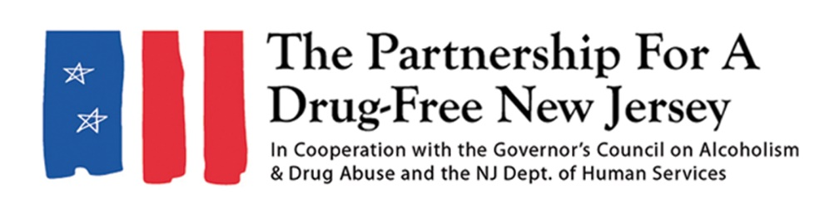
Social Media Tips
Let us know what you will be doing to spread the message about safer prescribing practices and the risks of prescription opioids on Knock Out Opioid Abuse Day. Please share your outreach highlights on social media, so we can emphasize your great work!
- Post photos and videos to Facebook, Instagram and Twitter with the hashtag #KnockOutOpioidAbuse
- Tag @PartnershipForADrugFreeNewJersey on Facebook or mention @DrugFreeNJ on Instagram and Twitter
- Email photos to media@drugfreenj.org
- Post before, during and after Knock Out Opioid Abuse Day about your outreach efforts

