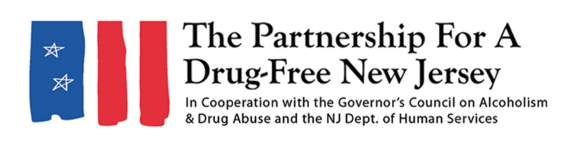
PLEASE CHECK WITH YOUR PUBLICATION FOR WORD LIMITS BEFORE SUBMITTING A LETTER TO THE EDITOR
Letter to the editor
In 2016, more than 42,000 people in the United States died of an opioid overdose.
As stunning and tragic as that figure is, the final death total for 2017 is expected to be even higher, and early data for 2018 indicates a continued rise in overdose deaths. New Jersey has not been spared from this crisis, which has claimed nearly 2,000 lives in the state so far this year.
On October 6, New Jersey volunteers will lead an effort to help protect families and communities from the tragedies of overdose and addiction.
Knock Out Opioid Abuse Day is a project of the Partnership for a Drug-Free New Jersey, in cooperation with the Governor’s Council on Alcoholism and Drug Abuse; the New Jersey Department of Human Services, Division of Addiction Services; and the Community Coalition for a Safe and Healthy Morris.
As part of the statewide single-day initiative, citizens will distribute vital information about the potential for dependency on prescribed opioids and their link to heroin use. The effort will have a dual focus: educating physicians and raising awareness among New Jersey residents and families.
While it’s becoming more difficult to ignore the tragedies associated with this epidemic, there are still many people who are unaware of the link between prescription opioids and heroin abuse.
A 2016 Partnership for a Drug-Free New Jersey study found that nearly one in three parents of New Jersey middle school students do not think there is a link between painkillers prescribed for things like sports injuries and wisdom tooth removal and the rising use of heroin in New Jersey. The study also found that less than 50 percent of parents of New Jersey Middle School students feel they are knowledgeable about heroin.
It's time to make sure every New Jersey resident is equipped with information that could help save lives. Please join us to help Knock Out Opioid Abuse on October 6.
Visit drugfreenj.org/knockoutvolunteers for more information and to sign up to volunteer.

