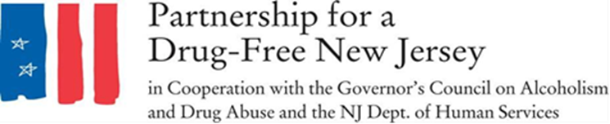
Letter to the editor
In 2015, more than 33,000 people in the United States died of an opioid overdose.
As stunning and tragic as that figure is, the final death total for 2016 is expected to be even higher, and early data for 2017 indicates a continued rise in overdose deaths.
The opioid crisis has reached epidemic levels, and there is no time to waste in addressing it.
On October 6, volunteers throughout New Jersey will lead an effort to raise awareness about the epidemic impacting our state and nation as part the second annual Knock Out Opioid Abuse Day.
The statewide single-day initiative will mobilize citizens to distribute vital information about the potential for dependency on prescribed pain medicine and its link to heroin abuse rates in our state. The effort will have a dual focus: educating physicians and raising awareness among New Jersey residents and families.
Knock Out Opioid Abuse Day is a project of the Partnership for a Drug-Free New Jersey, in cooperation with the Governor’s Council on Alcoholism and Drug Abuse; the New Jersey Department of Human Services, Division of Addiction Services; and the Community Coalition for a Safe and Healthy Morris.
While it’s becoming more difficult to ignore the tragedies associated with this epidemic, there are still many people who are unaware of the link between prescription opioids and heroin abuse.
A 2016 Partnership for a Drug-Free New Jersey study found that nearly one in three parents of New Jersey middle school students do not think there is a link between pain killers prescribed for things like sports injuries and wisdom tooth removal and the rising use of heroin in New Jersey. The study also found that less than 50 percent of parents of New Jersey Middle School students feel they are knowledgeable about heroin.
It's time to make sure every New Jersey resident is equipped with information that could help save lives. Please join us to help knock out opioid abuse on October 6.
Visit drugfreenj.org/knockoutvolunteers for more information and to sign up to volunteer.

