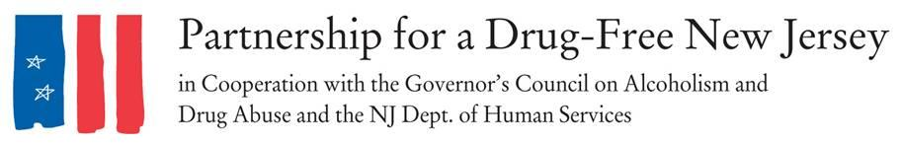
FOR IMMEDIATE RELEASE: INSERT DATE, 2017
Contacts: Matt Birchenough, 201-916-1032, media@drugfreenj.org

***MEDIA ADVISORY***
Volunteers Needed to Spread Awareness of Opioid Epidemic
For Statewide Knock Out Opioid Abuse Day Initiative
WHAT: On October 6, New Jersey legislators, concerned citizens, impacted families and substance abuse professionals will lead an effort to raise awareness of the opioid epidemic impacting our state in the second annual Knock Out Opioid Abuse Day.
Through this statewide single-day initiative, volunteers will spread the message about the potential for dependency on prescribed pain medicine and its link to heroin abuse rates in our state. The effort will involve a two-pronged approach: informing prescribers and raising awareness among New Jersey residents and families.
[INCLUDE INFORMATION ON LOCAL EFFORTS MADE IN YOUR TOWN/COUNTY LAST YEAR]
Knock Out Opioid Abuse Day is a project of the Partnership for a Drug-Free New Jersey, in cooperation with the Governor’s Council on Alcoholism and Drug Abuse; the New Jersey Department of Human Services, Division of Addiction Services; and the Community Coalition for a Safe and Healthy Morris, with help from thousands of volunteers across the state.
[INCLUDE A QUOTE FROM COUNTY COORDINATOR/OTHER ORGANIZER]
WHO: More than 2,000 volunteers participated in last year’s Knock Out Opioid Abuse Day, distributing crucial information on safe prescribing practices to physicians and dentists, as well opioid abuse prevention messages with information on the link between prescribed pain medications and heroin abuse throughout communities.
Volunteers will be asked to devote the amount of time they can give, whether it’s a few hours delivering door hanger tags to homes in their community or 20 minutes during their lunchbreak distributing materials in their office.
Anyone can volunteer: school clubs, scouts, religious groups, businesses. Coordinators for each county can provide more information on how to get involved.
[ADD OTHER EXAMPLES OF GROUPS THAT ARE INVOLVED IN YOUR COUNTY AND PROVIDE CONTACT INFORMATION FOR THE COUNTY COORDINATOR]

WHY: A recent study by National Institute on Drug Abuse revealed that about 41 percent of people who misused opioids obtained them for free from a friend or relative. Users of prescription drugs are 40 times more likely to use heroin, according to the CDC.
More than 33,000 people in the United States died of opioid overdoses in 2015, and the number of such deaths per year quadrupled from 1999 to 2015.
[YOU CAN ADD INFORMATION ON STATISTICS FROM YOUR COUNTY/TOWN]
WHEN: 10 a.m. to 3 p.m. October 6, 2017
WHERE: In communities throughout New Jersey [SPECIFY WHERE THE OUTREACH WILL OCCUR IN YOUR AREA]
FOR MORE INFORMATION: Visit drugfreenj.org/knockoutvolunteers. Interview and photo opportunities with volunteers mobilized throughout communities can be arranged.
###
Best known for its statewide anti-drug advertising campaign, the Partnership for a Drug-Free New Jersey is a private not-for-profit coalition of professionals from the communications, corporate and government communities whose collective mission is to reduce demand for illicit drugs in New Jersey through media communication. To date, more than $70 million in broadcast time and print space has been donated to the Partnership’s New Jersey campaign, making it the largest public service advertising campaign in New Jersey’s history. Since its inception, the Partnership has garnered 166 advertising and public relations awards from national, regional and statewide media organizations.

