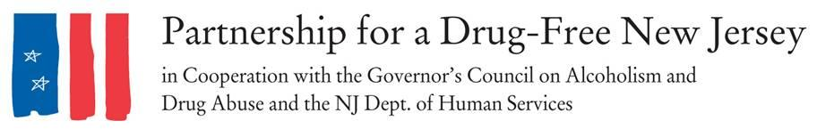
FOR IMMEDIATE RELEASE: Friday, Oct. 6, 2017
Contacts: Matt Birchenough, 201-916-1032, media@drugfreenj.org

More than 2,000 New Jerseyans Take to the Streets to Knock Out Opioid Abuse
INSERT LOCAL TOWN -- Friday throughout New Jersey, thousands of moms, dads, prevention and treatment professionals, students and concerned residents organized to raise awareness about the opioid epidemic impacting our state on the second annual Knock Out Opioid Abuse Day. INSERT LOCAL INFORMATION ON OUTREACH.
INSERT LOCAL QUOTE
In its second year, Knock Out Opioid Abuse Day increases understanding of the opioid crisis through a mobilization effort with a dual focus: educating physicians and raising awareness among New Jersey citizens and families. It is designed to bring attention to the opioid crisis facing the state and the steps residents can take to stem the epidemic. The New Jersey Senate and General Assembly responded following the first event in 2016 by unanimously approving joint legislation designating October 6 in perpetuity as Knock Out Opioid Abuse Day in New Jersey.
Knock Out Opioid Abuse Day is a project of the Partnership for a Drug-Free New Jersey, in cooperation with the Governor’s Council on Alcoholism and Drug Abuse; the New Jersey Department of Human Services, Division of Addiction Services; and the Community Coalition for a Safe and Healthy Morris, with thousands of volunteers across the state. INSERT LOCAL INFORMATION ON VOLUNTEERS
“Knock Out Opioid Abuse Day is an opportunity to engage New Jersey's medical community and families about safe prescribing and non-addictive alternatives to acute and chronic pain,” said Angelo M. Valente, Executive Director of the Partnership for a Drug-Free New Jersey. “We need to educate all residents and all prescribers with the most current research and protocols that if implemented will save lives and protect families.”
Teams of volunteers across the state visited physician and dental offices in their community to share the CDC Guidelines for prescribing. Volunteers urged prescribers to follow the guidelines in their own practice and provided information on local organizations and resources focusing on the opioid abuse epidemic for physicians to share with their patients. They also encouraged prescribers to discuss the dangers of opioids when they are prescribed, including the risk of dependency and possible alternatives that might exist.

Valente added that in neighborhoods throughout New Jersey, students, scouts and concerned families blanketed their community with “door knocker” hang tags for the front doors of local homes. These signs contained an opioid abuse prevention public service announcement with information on the link between prescribed opioids and heroin abuse.

“With the epidemic levels of opioid abuse impacting our state, the time to educate and raise awareness is now,” Valente said.

According to the CDC, opioid pain relievers that are abused were most often obtained via prescription from physicians, and users of prescription drugs are 40 times more likely to use heroin. More than 33,000 people in the United States died of opioid overdoses in 2015, and the number of such deaths quadrupled from 1999 to 2015.

According to the American Academy of Pediatrics, legitimate opioid use before high school graduation is independently associated with a 33 percent increase in the risk of future opioid misuse after high school. Use of prescribed opioids before the 12th grade is independently associated with future opioid misuse among patients with little drug experience and who disapprove of illegal drug use.
Interview and photo opportunities with volunteers regarding their outreach are available.
###
Best known for its statewide anti-drug advertising campaign, the Partnership for a Drug-Free New Jersey is a private not-for-profit coalition of professionals from the communications, corporate and government communities whose collective mission is to reduce demand for illicit drugs in New Jersey through media communication. To date, more than $70 million in broadcast time and print space has been donated to the Partnership’s New Jersey campaign, making it the largest public service advertising campaign in New Jersey’s history. Since its inception the Partnership has garnered 166 Advertising and Public Relations Awards from National, Regional & Statewide Media Organizations.

